
CCNP – Local AI Installation
Ian – CCNA

Purpose:
Data Privacy and Data Protection are among the top concerns with usage of public AI models. Many parents and families are concerned that it creates the potential of violating FERPA. Many parents and families are concerned that it creates the potential of violating FERPA. Students and teachers can unknowingly leak private information to AI models which becomes the property of the AI. The potential for such an attack on privacy has only grown larger as AI models have become increasingly sophisticated and can now record and use information received from conversations with users. Installing AI models locally prevents private information from being leaked. The purpose of local AI models is to protect sensitive data and privacy while offering the same quality and experience.

Background:

What is a Large Language Model (LLM)?
A large language model is what we call a type of advanced AI system. In a nutshell, it’s a collection of billions of megabytes of data that is fed through an algorithm so that it can generate human-like responses to inputs and tasks given by users. Recently, these LLMs have developed to be able to generate visual art on top of text responses. Some LLMs gather even more data from the web and inputs after their initial training to improve the quality of their responses.
LLMs are trained using large quantities of data to recognize patterns and identify facts. Using those patterns, LLMs can predict things like the most probable word to come next in a sentence or the answer to a certain question. The more data a model has access to, the more it can be trained to fine tune the accuracy of its results.
Another solution AI developers have used to improve the accuracy of their models is specializing in different models to be highly trained in one field. Models are given networks of data specific to a single field which vastly increases the model’s accuracy relating to one field. Because of this, data regarding other topics can be removed, allowing these models to use smaller networks or data, which reduces the computational cost of the model.
LLMs started with the creation of Eliza in the 1960s by MIT researcher Joseph Weizenbaum. It was first used to research natural language processing or NLP. This historical step sets the stage for further research and development of computer and human communication. Research in this field during the following decades focused on expanding the model’s ability to process data and creating complex neural networks. One of the first models representing the modern models was BERT. This LLM used its 340-million parameter model, massive for its time, to accurately predict and decode words from texts. Developers would continue to feed their models with larger sets of data and computational power, further increasing their accuracy and speed. Now, they work to also train different AI models to specialize in a certain topic, greatly increasing accuracy while also decreasing the cost and needing to expand their data sets.

What are the Uses of LLMs?
LLMs have been used for many purposes because of their ability to mimic human language and “thought” using their algorithms and massive data collections. Because of this, LLMs can be used to generate responses to simple tasks, to help students study by summarizing lectures and explaining concepts, and other things like helping businesses respond to customers quicker and more effectively. LLMs are most known for their use as generative AI.

What is a local LLM?
A local LLM is a large language model that you can run on a device itself. These language models don’t require access to the internet, giving users full function off the grid. Local LLMs provide the same functions as regular LLMs including the generative-AI feature. The only difference is that local LLMs are separate from the internet and can be modified locally to the user’s desire.

What are the benefits of a local LLM?
A local LLM gives users the benefit of much more control over their AI model and user traffic. This model can be specialized according to the preferences of the user. It can also stop the model from adding data from user interactions to its data set. Although this limits the fine-tuning of the model’s results, it can be used to protect the privacy of users. This benefit is great for organizations dealing with sensitive information that should not be shared with the rest of the world. Local LLMs are completely independent of the internet, meaning user traffic doesn’t ever have to leave the privacy of an office or home.

Configuration:

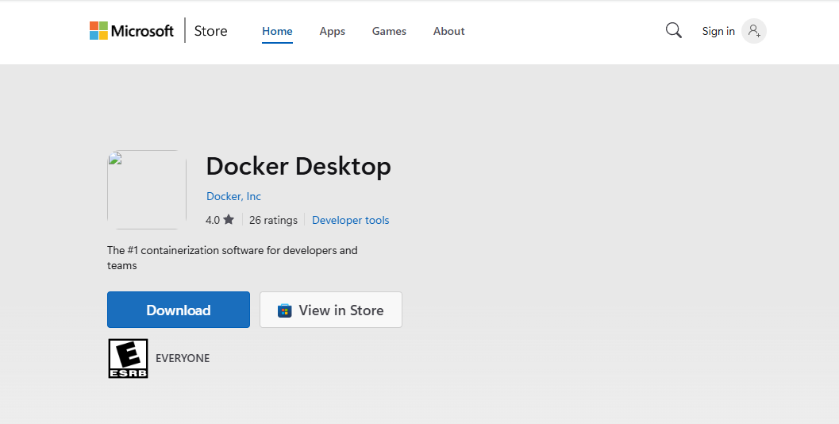
Docker Download
For this lab we will need to download Docker which will be used to create the container for the localhost platform.
Head to the Microsoft Store and find the Docker Desktop application.
Click download and wait until the download is complete. This downloads the Docker_Desktop_Installer.exe file which will be used to download Docker.
Link: https://apps.microsoft.com/detail/xp8cbj40xlbwkx?hl=en-US&gl=US

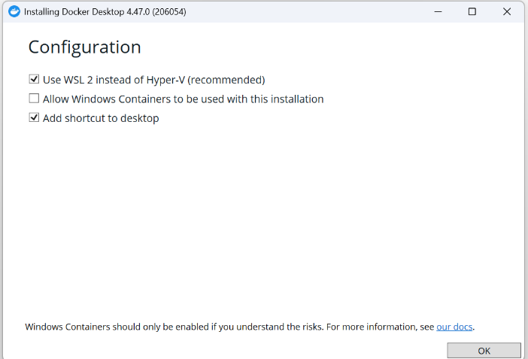
After the download has been completed, open the file and customize the settings as you desire. We recommend you select “Use WSL 2 instead of Hyper V”.

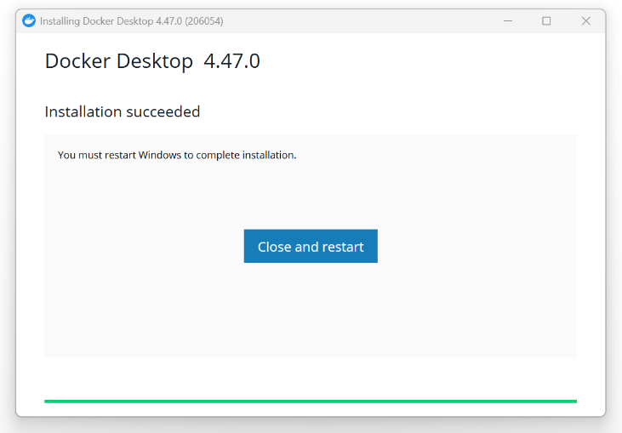
After clicking “OK”, finish the download and click “Close and restart”. The restart is necessary to apply the new changes to the PC and allow the installer to enable certain features.

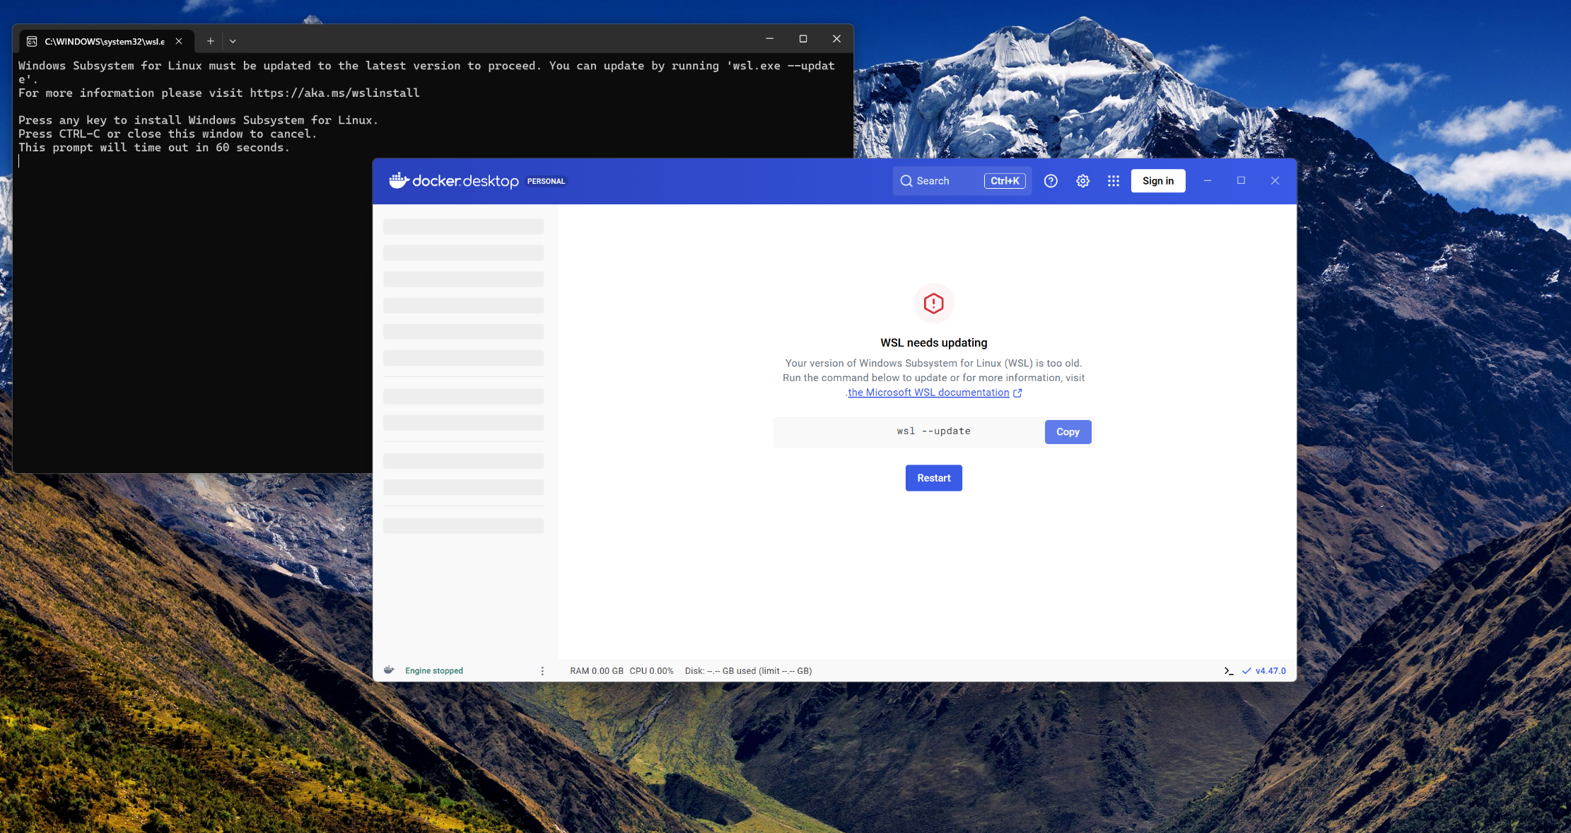
WSL Update
After restarting, open up Docker. You may be prompted to update your version of WSL.

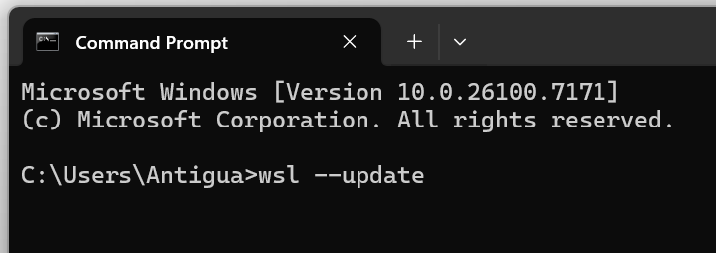
Copy the command from Docker and paste it into command prompt. Your system will check for any WSL updates and will update if needed. Restart your computer if needed or prompted by Docker.
After completing these steps, Docker will be fully functional and ready for use to set up your local Ollama LLM.

Ollama Download

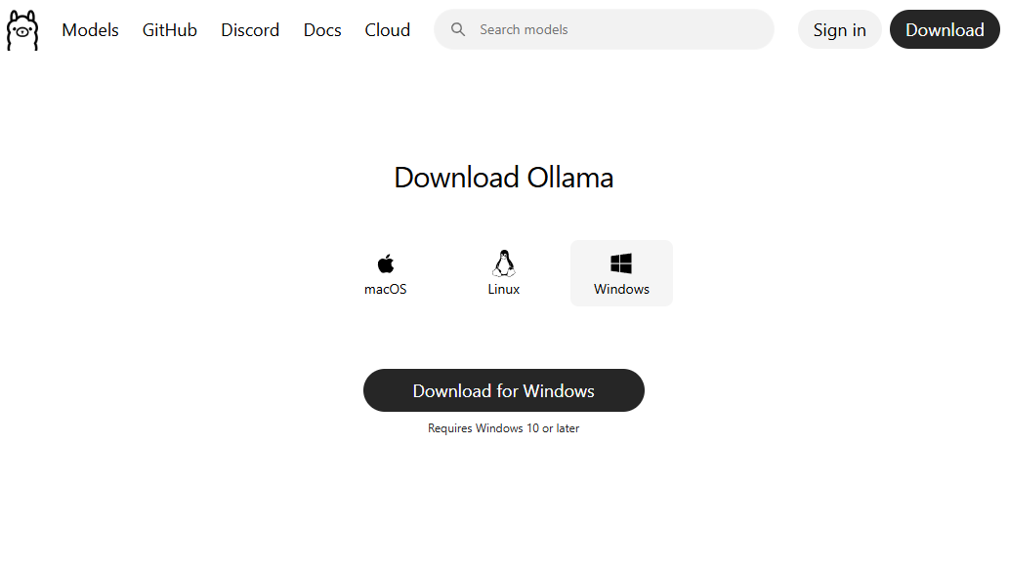
The Ollama download is not necessary, but I have included it here if you would like to do so. Go to Ollama and download the version for Windows. Link: https://ollama.com/download/windows

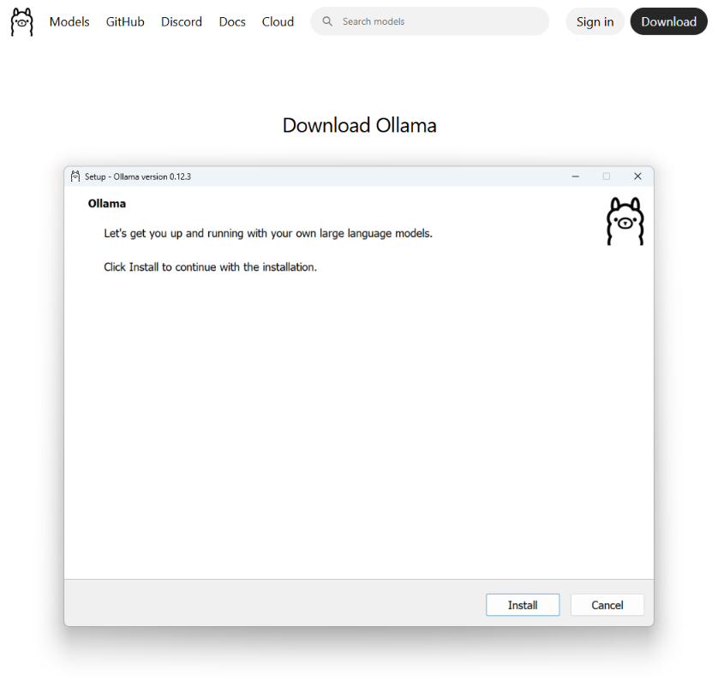
After the download is complete, open the file, which is named OllamaSetup.exe, and select the customization settings you desire. After selecting the setting you desire, click “Install” to install Ollama.
After Ollama has finished installing, it is free to be used as the user desires.

Setting up the localhost WebUI (using WebUI & Docker)
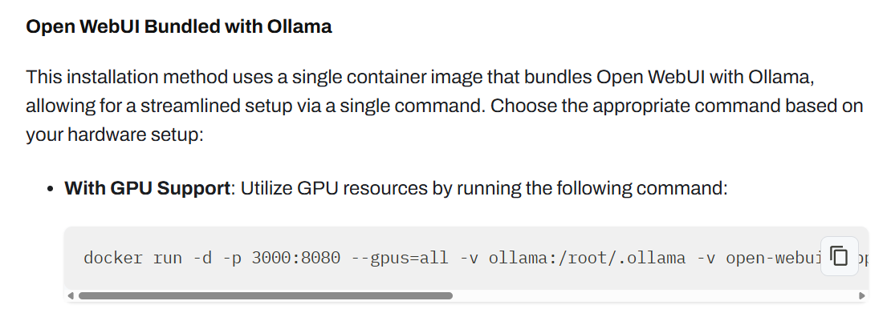
Go to the Open Web UI website and look for the configuration “With GPU Support”, under “Open WebUI Bundled with Ollama”.

Copy that configuration and paste it into command prompt.
Link: https://docs.openwebui.com/

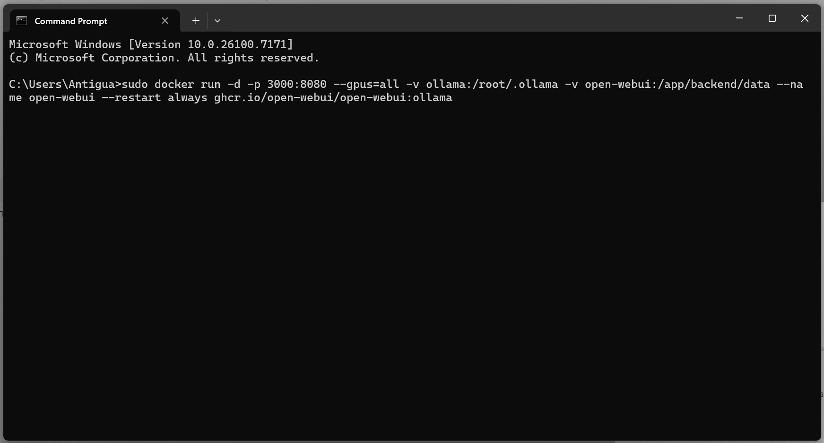
If the command is not accepted into command prompt, type sudo and then paste the command as seen in the image above. The command sudo runs the command with administrative privileges which bypasses restrictions which would have otherwise prevented the command.

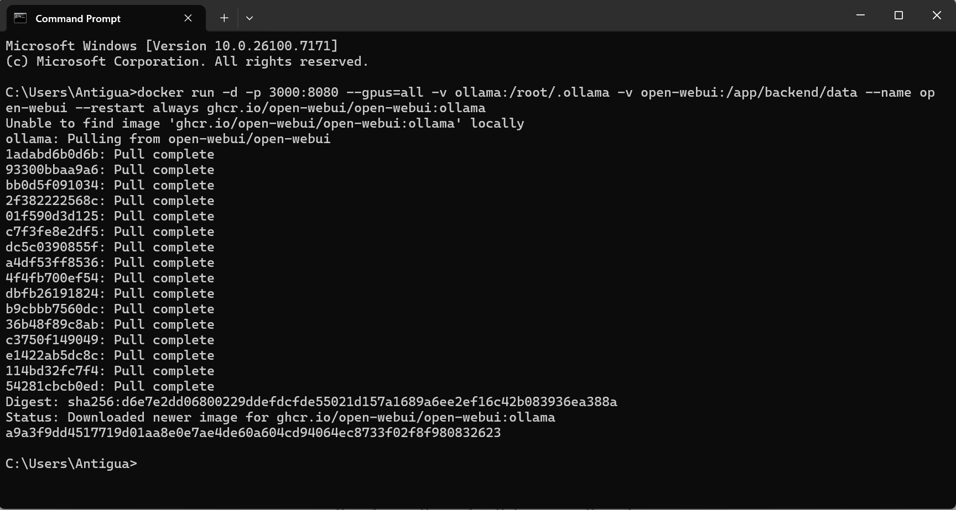
When the download completes, like the image above, we can now access our local WebUI.
Accessing our Local WebUI

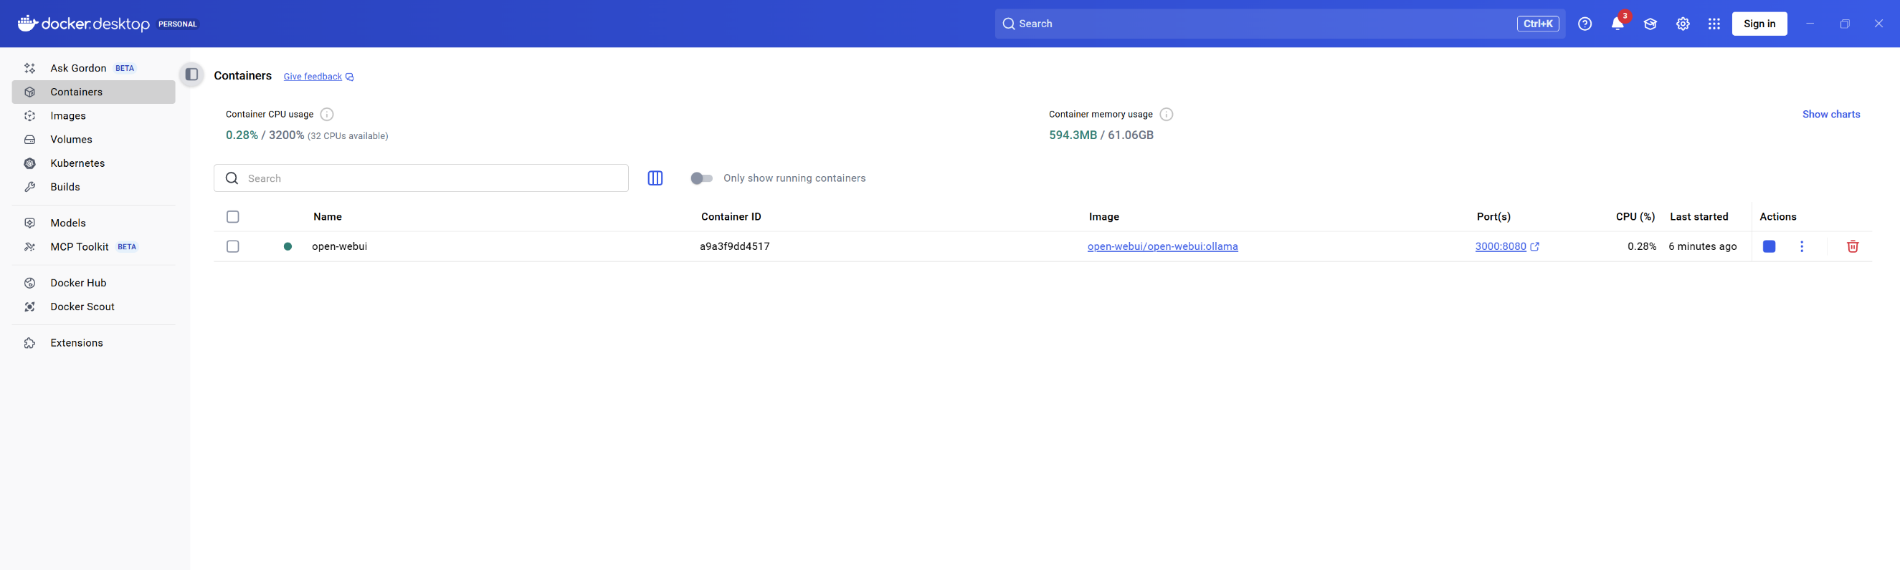
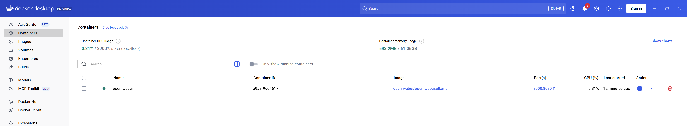After the download, you have created a container in docker. Navigate to the “Containers” tab in Docker (to the left). Then check to see if the container you have made is in Docker (above.) You also want to check for the green dot (like the image above), which shows that the container is active and available.

If the container exists, and is active, go to the localhost WebUI and access your local LLM. To access your localhost WebUI go to this site: http://localhost:3000. This will bring you to a log-in page, where you will need to create an account. After creating an account, log in and access the WebUI!

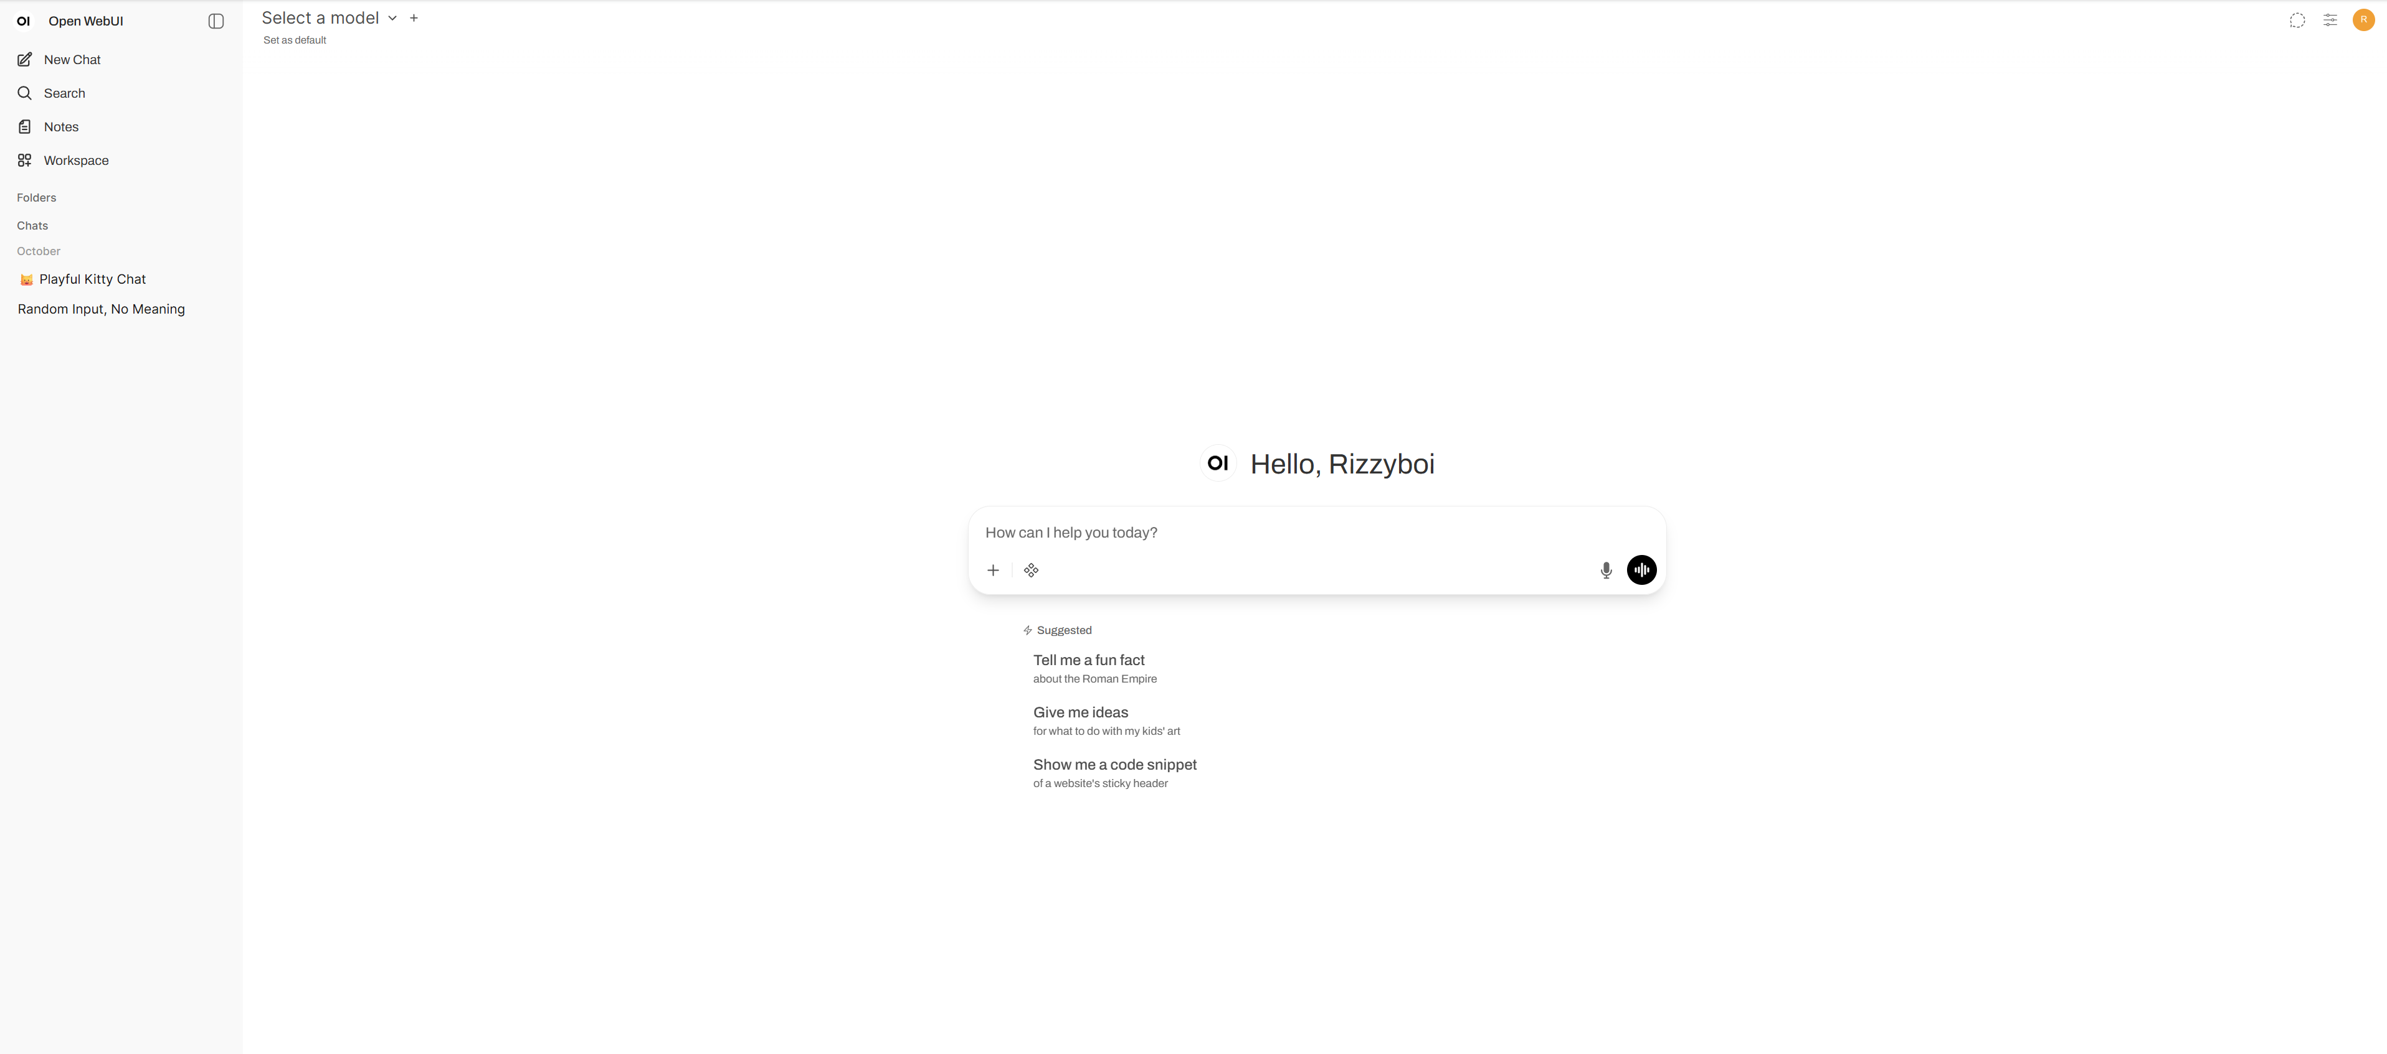

Downloading your Local LLM
Click on your profile’s icon, then select “Admin panel”. Then select “Setting” and finally “Models.” Or you use the link given below.
Link: http://localhost:3000/admin/settings/models
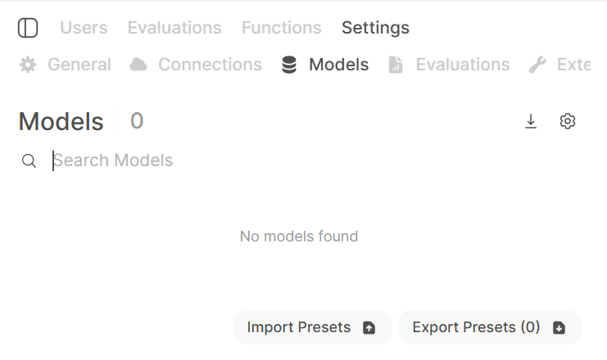
As seen in the photo, select the download icon to begin downloading your LLM from Ollama.

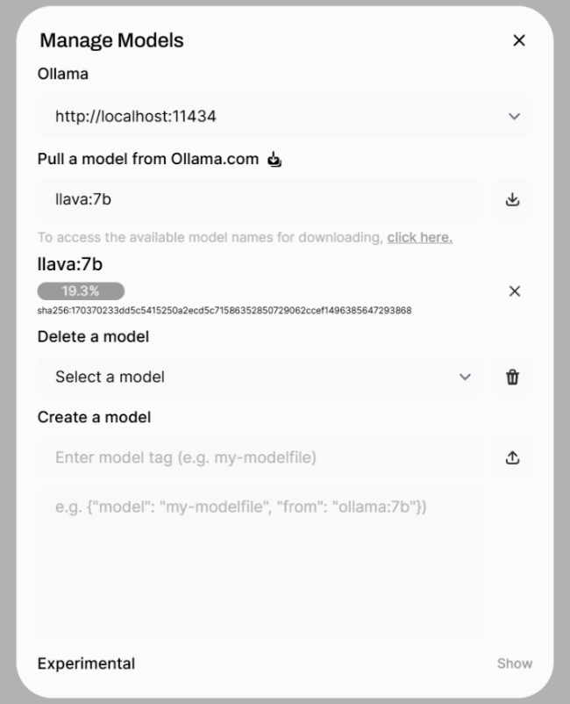
You will be brought to this screen seen in the photo the right. Then, after finding the Ollama LLM that you desire put the name of the model in the box under “Pull a model from Ollama.com”. You can visit: https://ollama.com/search, to find the Ollama model that you desire. For this lab, we chose the model lava:7b. Then click the icon beside your input to download the model.

Using the Local LLM
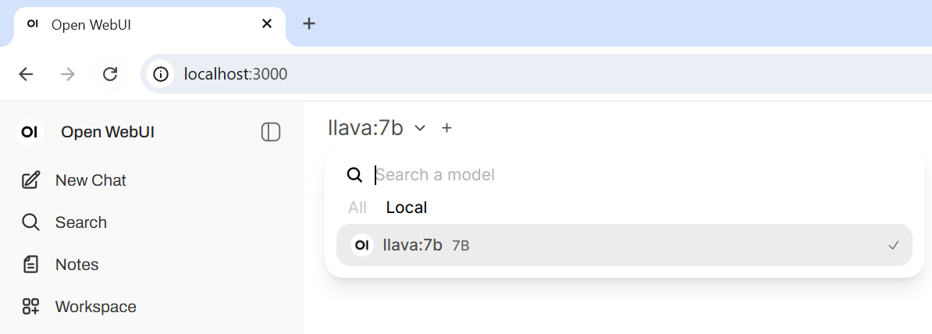
Go back to the general tab (by clicking “Open WebUI” or http://localhost:3000). Then, click the select model button and choose “Local” to find the model you have locally downloaded. And there you go, you have successfully downloaded a local LLM!

Accessing the localhost site Wirelessly
In command prompt, type the command ipconfig to see the ip of your PC.

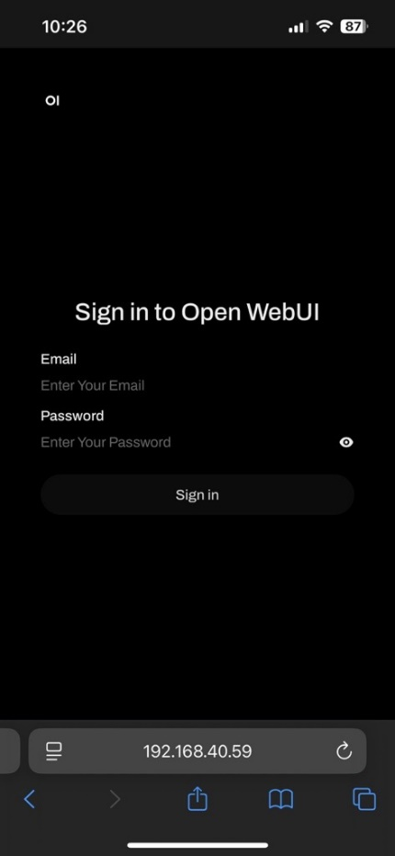
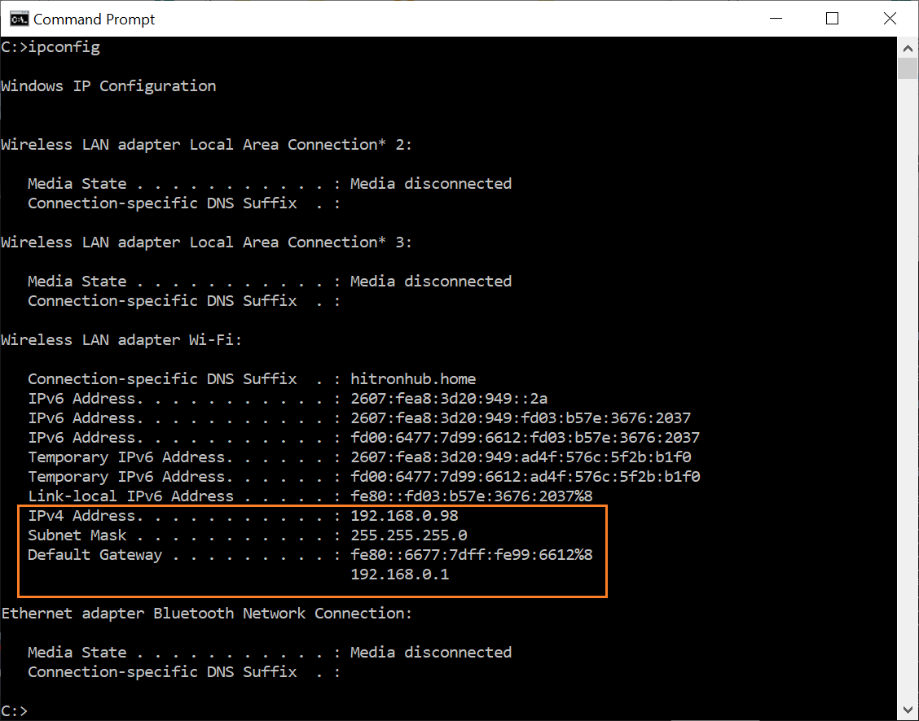
Then look for the ip address of your PC. After making sure that your PC and wireless device are on the same network, type in the IP of your PC into your wireless device to wirelessly connect to your localhost site!

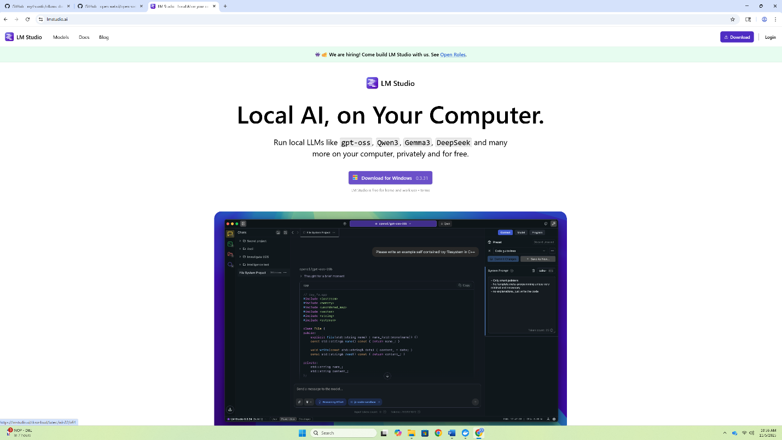
Implementing Local LLMs with LM Studio
Go to LM Studio website: https://lmstudio.ai/download and download the LM studio
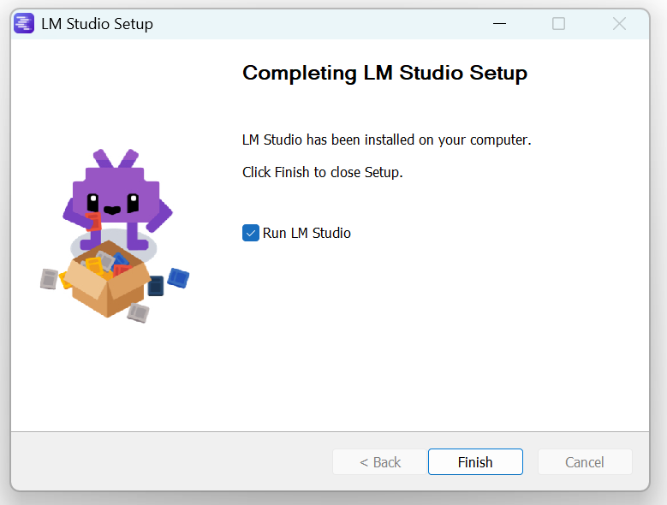
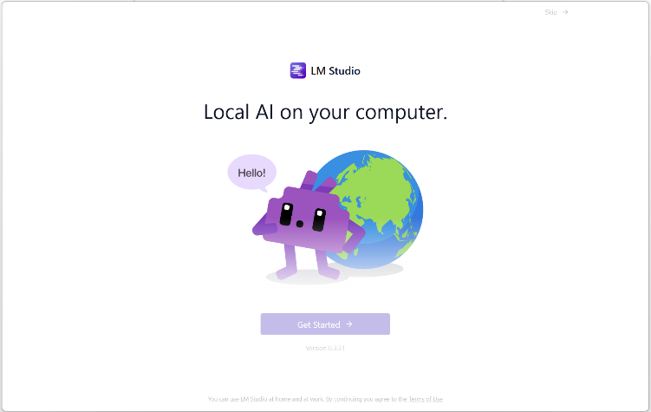
installer.

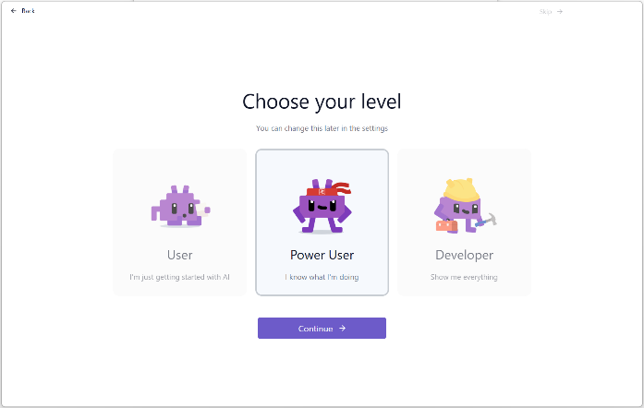
Then use the installer to download the LM Studio application. After the application finishes downloading, select “Get Started”.

Select Power User to get started with LM Studio.
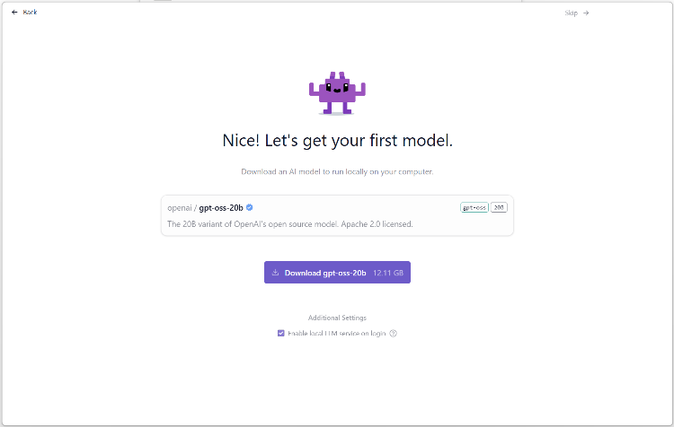
If you are met with this screen after selecting Power User, look for the skip icon in the top right corner.

Downloading your Local LLM

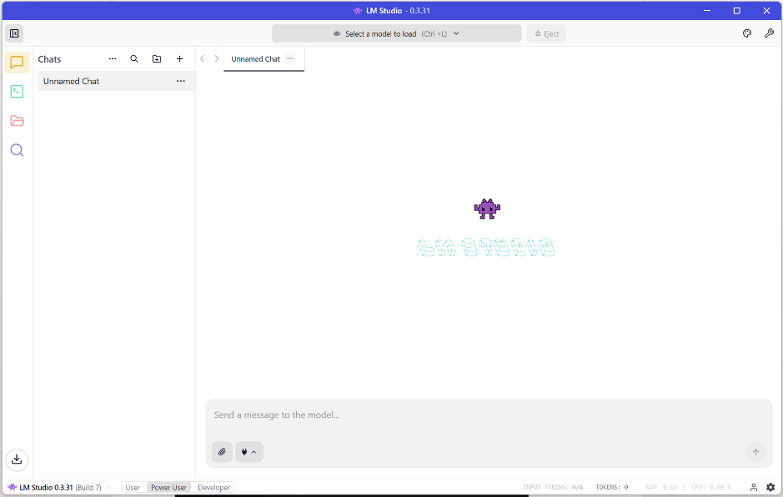
After pressing skip, you will be met with a lot of introductory pop-ups. If you would like, go through the introductory tutorial. But the next step is to click in the search bar (“Select a model to load”).

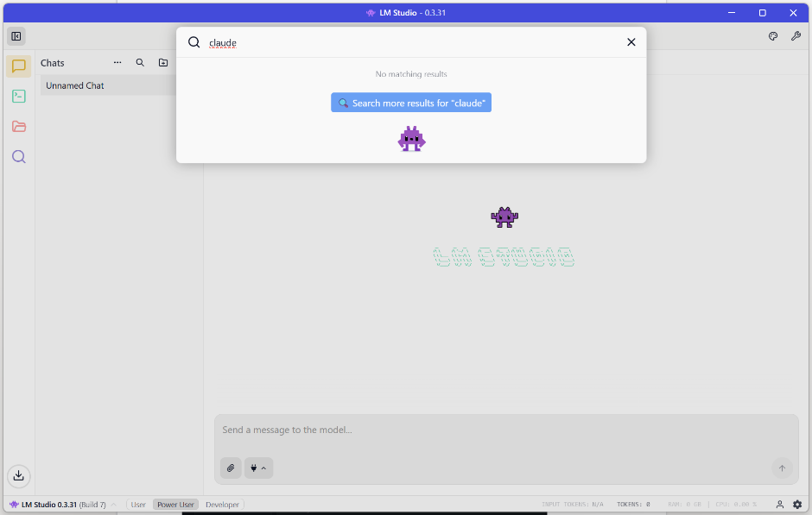
Then, type in the name of the LM Studio model you would like to download. In this example, we are going to download the claude LLM. Press Enter to search.

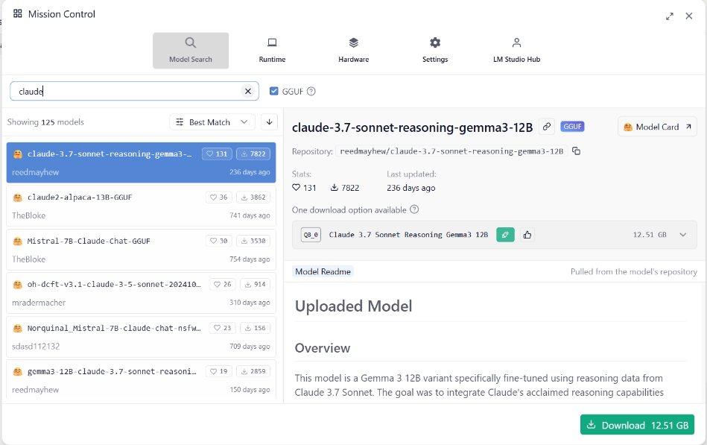
After finding the desired model, click the green “Download” button in the bottom right corner. The download will take a while.

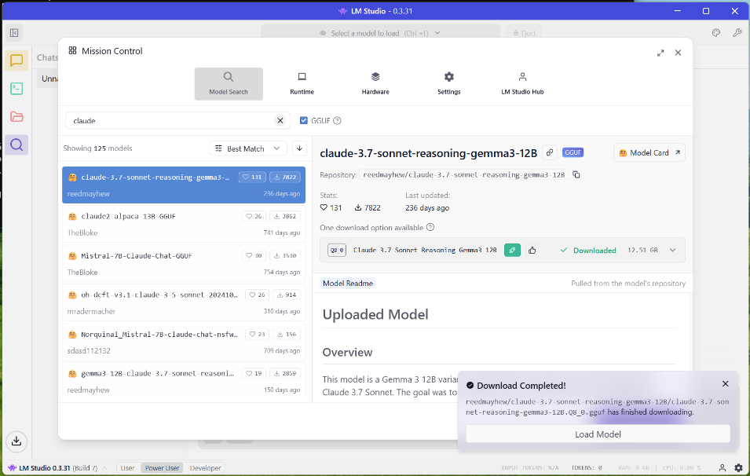
After the model finishes its download, a Download Completed popup with appear. Click “Load Model”. After loading the model, you should be opened up into a new chat!

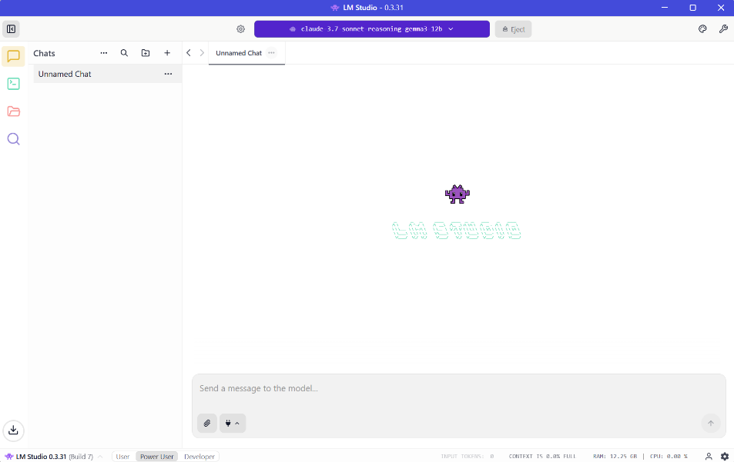
Then, your Local LLM has been downloaded successfully! Type into the chat box to interact with your Local LLM.

Problems:
When installing the container using the code from WebUI, I mistakenly downloaded the version with NVIDIA GPU support but without Ollama bundling. This mistake factored into may issues, like the inability to download Ollama models either efficiently or completely. This hindered my ability to properly download a local LLM even though I had set up a localhost site and everything.
The solution to this problem was to go into docker and delete the container with the wrong bundling. I first had trouble deleting the container because the container was “always active or in use”. The solution to that problem was to select the container, then pause the process, and finally delete the container. Then, I went back into Open WebUI and downloaded the correct version bundled with GPU support and Ollama. This allowed me to finally download the Ollama model locally and complete the lab.

Another problem I had was getting the wireless device to connect to the PC’s localhost site. I had found the PC’s IP, connecting both to the same network, and searched for the localhost site using the correct IP.
The solution to the problem was turning off the window’s defender firewall. The firewall was stopping my phone from making a connection wirelessly to the PC, and as a result, wasn’t able to connect to the site. Turning off the firewall allowed the wireless device to finally access the site.
Another solution to this is going onto the PC and allowing certain inbound traffic. In this case, we used ports 3000 and 8080. So, on the PC’s firewall, we can set an inbound traffic rule to allow those two ports. This would allow the wireless devices to connect to the site while also maintaining security by preventing other unwanted traffic.

Conclusion: Although AI seems to be out of human control, using local LLMs, we can moderate and limit the exposure of private information onto the web. Local LLMs are a powerful tool that we as networking engineers can create to allow students or other users to have full access to the benefits of AI technology while also protecting them from the many safety hazards and concerns. Using local LLMs, we would be able to implement and follow the rules and standards of FERPA for the protection of the next generation from identity theft or other problematic issues that stem from data being put into the wrong hands. Thus, this lab serves as a guide for students, families, and others to protect their data and have a good understanding of what Local LLMs can do.

